MPCA ASSIGNMENT - 1

NAME: Rachappa

SRN: PES1UG19CS359 SECTION: B

ROLL NO :1

Problem 1:

Write a program in ARM7 TDMI ISA to search for an element in an array. Display app messages on the standard device. Successful search should display “Search is successful”. Unsuccessful search should display “search is unsuccessful”. Use binary search technique.

CODE:

.data

elementFound: .ASCIZ "Given Number Exist" elementNotFound:

.ASCIZ "Given Element Does Not Exist" size: .word 8

list: .word 10,20,30,90,100,200,300,400,900 searchElement: .word 900

.text

LDR r1,=size LDR r1,[r1]

LDR r2,=list MOV r3,#0

LDR r10,=searchElement LDR r10,[r10]

START: CMP r1,r3

Bge LOOP B NOTFOUND LOOP:

ADD r4,r1,r3

MOV r4,r4,lsr #1

LDR r5,[r2,r4,lsl #2] CMP r5,r10

BLeq FOUND

BLgt GREATERTHAN BLlt LESSTHAN

B START LESSTHAN:

ADD r3,r4,#1

MOV pc,lr GREATERTHAN:

SUB r1,r4,#1

MOV PC,LR FOUND:

LDR r0,=elementFound SWI 0x02

B EXIT

NOTFOUND:

LDR r0,=elementNotFound SWI 0x02

B EXIT EXIT:

SWI 0x11

OUTPUT:

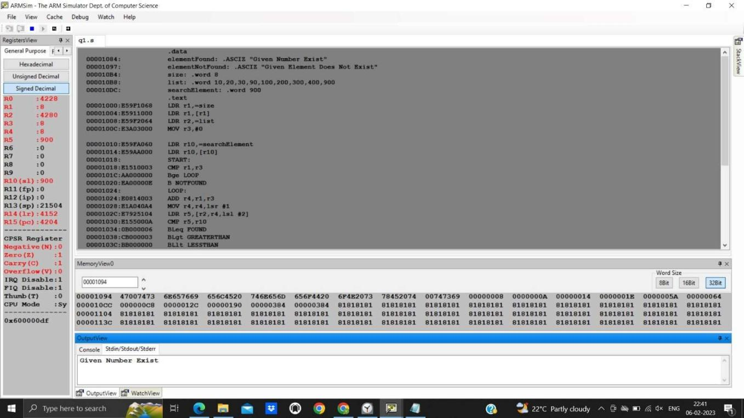

Problem 2:

Write a program in ARM7 TDMI ISA to find a substring in the given main string.

CODE:

.data

exist: .ASCIZ "String is Present." notExist: .ASCIZ "String not Present." string: .ASCIZ "MISSISSIPI" substr:

.ASCIZ "ISSIP"

.text

LDR r1,=exist LDR r2,=notExist LDR r3,=string

LDR r4,=substr LDRb r6,[r4],#1 LOOP:

LDRb r5,[r3],#1 CMP r5,r6

STMFD R13!, {r3,r4} BLeq CHECK

CMP r5,#00

Beq NOTFOUND Bne LOOP

B EXIT CHECK:

LDMFD R13!, {r7,r8} WHILE:

LDRb r9,[r7],#1 LDRb r10,[r8],#1 CMP r10,#00 Beq FOUND CMP r10,r9 MOVne PC,LR B WHILE

FOUND: MOV r0,r1 B OUTPUT

NOTFOUND: MOV r0,r2

B OUTPUT OUTPUT: SWI 0x02

B EXIT EXIT:

SWI 0X11 OUTPUT:

